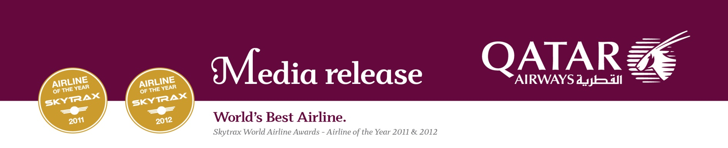

QATAR AIRWAYS PARTNERS WITH KIDZANIA KUWAIT FOR NEW CHILDREN’S ENTERTAINMENT AND EDUCATION CITY

Airline To Sponsor Aviation Section Of Facility In Kuwait Shopping Mall

Youngsters Gain Insight Into Aviation World; Role Playing Pilots & Cabin Crew

8 April 2013

Kuwait City, KUWAIT – Qatar Airways today announces an exciting partnership with KidZania Kuwait, an award-winning children’s city concept globally recognised for its unique blend of education and entertainment.

KidZania Kuwait will offer youngsters an array of interactive entertainment and learning activities in a new 7,000 sqm children-centric city experience, where visitors have an opportunity to role play real life activities such as being aviators.

Doha-based Qatar Airways will be sponsoring the aviation activities of KidZania Kuwait, where there will be airport counters and a mock-up Boeing 777 aircraft giving visitors an insight into the world of airlines.

As pilots, children will learn about the cockpit, control panels and take-off and landing manoeuvres using state-of-the-art flight simulators.

Youngsters can also role-play cabin crew duties such as carrying out safety procedures and serving food and beverages.

KidZania has a similar set-up in almost a dozen cities around the world where youngsters are able to live up their dreams.

Expected to open doors in a few months at the largest shopping mall in Kuwait – The Avenues – KidZania Kuwait will offer 78 roles and 100 engaging activities – all reflecting real life professions and businesses such as being a police officer, shopkeeper, doctor, journalist, as well as a pilot and cabin crew.

Qatar Airways announced the partnership with KidZania at a press conference held in Kuwait’s capital Kuwait City, where the airline’s Senior Vice President GCC, Levant, Iran, Iraq & Indian subcontinent, Fathi Al Shehab spoke of how children’s dreams can turn to reality at KidZania Kuwait.

“Qatar Airways is delighted to be part of this exciting opportunity that will enable children in Kuwait and visitors from across the region to experience Qatar Airways first hand through this educational and entertaining facility.

“Through KidZania’s unique offering, children fascinated with aviation will be able to live out their dream in an enjoyable and interactive environment. We are also looking forward to developing today’s aviation enthusiasts to become tomorrow’s aviators, and help them build a strong bond with our airline.

“Kuwait is one of our high-traffic Gulf routes with eight daily flights linking Kuwait with our Doha hub and onward connections to over 125 key business and leisure destinations across the world.”

Fernando Medroa, Vice President of Leisure and Entertainment at M.H. Alshaya, which operates the franchise of KidZania Kuwait’s operators, added: “We are thrilled to have Qatar Airways, one of the world’s fastest growing airlines, as the sponsor of KidZania Kuwait’s airport counters and airplane activities.

“We are certain that with Qatar Airways on board, children will develop an understanding of various aviation roles by being immersed in a real-life aviation environment, provided by Qatar Airways’ renowned state-of-the-art inflight experience.”

At the press event, journalists and guests were greeted by KidZania’s mascots Urbano, Vita, Bache, Chika and Beebop who embody KidZania’s values.

Designed to educate and inspire children into their early teens, KidZania Kuwait will help youngsters learn about working life in a fun and engaging way by offering a kid-sized city experience, all in a safe and self-contained scaled-down city.

As children enter KidZania Kuwait, Qatar Airways’ airport check-in counters will serve as access points to gain entrance into the theme park. Children will also be exposed to real-life aviation experiences within the mock aircraft located inside the park. The aircraft interiors will represent Qatar Airways’ flagship long-haul Boeing 777 cabin and in-flight service.

Qatar Airways currently operates a modern fleet of 122 aircraft to over 125 destinations globally, including destinations in Europe, Middle East, Africa, Asia Pacific, North America and South America.

Qatar Airways is set to launch flights to a diverse portfolio of new routes, including Chicago, USA (April 10); and Salalah, Oman (May 22); Basra, Iraq (June 3); and Sulaymaniyah, Iraq (August 20) and Chengdu, China, at a date to be announced with many more new destinations planned.

-ends-

Notes to Editors:

About Qatar Airways:

Qatar Airways currently has orders worth over US$50 billion for more than 250 aircraft, including Boeing 787s, 777s, Airbus A350s, A380s and A320 Family of aircraft. In addition to winning Skytrax’s prestigious Airline of the Year 2011 and 2012, Qatar Airways was named Best Airline in the Middle East for the seventh year in a row, and its Premium Terminal at Doha International Airport was named Best Premium Service Airport for the second consecutive year in 2012. Skytrax is the only global independent passenger survey monitoring airline standards and is considered the ultimate benchmark for excellence in the airline industry. In October 2012, Qatar Airways became the first of the major Gulf carriers to officially join a global alliance having been invited into the oneworld group. For more information, visit www.qatarairways.com

About KidZania:

KidZania creates a children-centric city experience designed to educate and inspire 4 to 14-year-olds - from arriving at the airport, to visiting a city centre and exploring city streets, replicating the real world in a safe and self-contained over 7,000 square metre children-sized city. KidZania operates just like a real city complete with buildings, paved streets, vehicles, a functioning economy and recognisable destinations in the form of "establishments" sponsored and branded by leading multi-national and local brands. The facilities are designed to educate through experience, fostering the development of life skills, but from a children perspective - it's all about fun.

KidZania, Inc., headquartered in Mexico, is privately held. This award-winning concept is recognized globally for its unique blend of entertainment and education for children. The first KidZania opened in Mexico City in 1999. There are ten other locations including, Monterrey (Mexico); Tokyo, Jakarta, Koshien, Lisbon, Dubai, Seoul, Kuala Lumpur, Cuicuilco (Mexico) and Santiago (Chile). To date, more than 20 million kids and parents have visited the facilities globally. Further KidZania locations are planned in Jeddah, Bangkok, Sao Paulo, Moscow, Mumbai, Istanbul, Cairo, London and the United States. For more information on KidZania Kuwait, visit www.kuwait.kidzania.com.

FOR QATAR AIRWAYS CORPORATE IMAGES VISIT THE FOLLOWING WEBSITE:

(PLEASE NOTE: Select Images And Open On Desktop)
FTP URL: ftp://ftp.qatarairways.com.qa
User Name: qrcomms
Password: O4Au2006

For further information
Qatar Airways Group, Corporate Communications Department
Tel: +974 44302072, Fax: +974 44302069
E-mail: qrmedia@qatarairways.com.qa
Website: www.qatarairways.com

